Rebecca Exley September 2016

Institution; Royal London Hospital, Whitechapel
Supervisor; Professor Simon Holmes. Consultant in Craniofacial Traumatology, Oral and Maxillofacial Surgery

For consideration at the BAOMS Endowments Sub-committee meeting

Introduction

The principle aim of my project was to improve the understanding of facial trauma patients following injury. Moreover, to facilitate communication of the anticipated management plan, consent process, outcomes and answer any common questions. The complexity of the information to be conveyed is a recognised barrier to obtaining valid informed consent.

The project aspires to set standards for the clarity and quality of the information presented. Thereby achieving a set level of understanding independent of the grade and experience of the consulting clinician (SHO, registrar or consultant).

Project

The project was carried out at a major London trauma centre with a heavy throughput of facial trauma cases.

Hospital Trauma leaflets

The Oral and Maxillofacial (OMFS) department used the trust patient information leaflets. These printed leaflets were readily available in the Dental Hospital, and were therefore frequently used during the Oral and Maxillofacial trauma clinic (conducted in the Dental Hospital).

During this project it became apparent that elective and semi-elective trauma patients were benefiting from information leaflets. This was in contrast to acute trauma patients whom received an operation during their inpatient stay, having avoided trauma clinic preoperatively during their patient journey.

There is an inherent difficulty in ensuring that trauma leaflets are available in A&E due to the turnover of patients. Of note, there are official BAOMS patient information leaflets available at www.baoms.org.uk. Theoretically these would be more accessible within a busy A&E department, however viewing restrictions placed on trust computers mean that sites are frequently blocked. Notwithstanding, we felt that it is important for the clinician to be familiar with the material and therefore would benefit from using a single source.

A further criticism of the trust leaflets is that they are syntax and text heavy and do not contain illustrations.

Patient feedback and project evolution

When obtaining informal feedback from patients passing through both A&E and the Oral and Maxillofacial Trauma Clinic a number of themes emerged. Patients felt it important to be able to engage with the material provided. They valued the ability to be able to review the information given at a future convenient time. Portability was also a key factor. Customisation to their individual pattern of injury was also valuable.

Regarding age demographic of trauma patients according to one study the average age for a facial trauma patient is 29.6 years with a male preponderance (1). This is comparable to our experience.

Telemedicine

The World Health Organisation (WHO) defines telemedicine as use of “Information and Communication Technology (ICT) to improve patient outcomes by increasing access to care and medical information” whether asynchronous, involving the exchange of pre-recorded data, or synchronous involving the immediate and real-time exchange of information (3). A myriad of ICT such as computers, internet and mobile devices are involved in the delivery of telemedicine. Consequently, ICT literacy and accessibility represent a barrier to telemedicine diffusion (4).

In a 2015 study by Deloitte, UK smartphone ownership is 72%, growing by 14% in 10 months (5). The highest proportion of smartphone ownership is in the 16-35 age group.

Innovative solution

Armed with feedback and the overwhelming proportion of smartphone ownership, we felt the most appropriate solution was to create a free smartphone application, which the patient can download onto his/her device. Although ICT is a prerequisite for its use we felt that we were responding appropriately to the demographic and needs of our patient population.

By definition the material would also be viewable on a tablet or desktop computer. With viewing capability on multiple devices, we are able to maximise the ease at which a patient is able to download and view the information. Instant download using 3G/4G/trust intranet/cloud wifi would circumvent any difficulty accessing material dependent on location of the consultation.

An option considered was the development of video content. However, it was felt that this would be too distracting during the consultation, and that an interactive leaflet would be a happy medium; serving as an adjunct to the consultation and not simply replacing it. Furthermore, after careful consideration it was decided that intraoperative video content would most likely be too graphic, and cause the patients to disengage with the resource.

Layout

We felt that it was important to create a central trauma matrix, which will form the home screen of the application (appendix, figure 1). This would allow the user to navigate the following categories; general, NOE and nasal, maxillary, mandibular and incisions and approaches. Each of these categories are subdivided allowing the user to click through selecting the information that is relevant to them and their injury. The app will make it possible to collate pieces of information thereby creating a customised information source. This patient information leaflet can then be printed, or saved as a PDF to iBooks (or any other compatible app), or shared via email.

Furthermore, we are looking on a further functionality to generate a ‘PDF booklet’ whereby the user can select exactly which trauma leaflets they want to be generated, and this will be performed as an automated process and complied into a single booklet.

App development

The templates have been developed using FileMaker Go available from the iOS app store. The resolution has been developed for use on the 9.7-inch iPad, but has been adapted for both larger and smaller screens.

The app is currently with the developers. We anticipate the finished product will be available for download in a number of months.

Although it is often recommended that information leaflets are produced in landscape format, we elected to produce ours in portrait format to aid readability on a smartphone or tablet.

Language

It is recognised that many patients have poor reading skills and therefore health literacy. We have followed the usual procedure of submitting the proposed content to the communications department of the trust. This ensures that the content is understandable for the average reading age of the population the content is aimed at. This is equivalent to achieving NHS information standard certification.

Furthermore, we also followed best practice guidance on the content and structure of the information resource (6). Specifically, complex language was avoided utilising words of few syllables. Sentences were restricted to less than 20 words. Long paragraphs are known to confuse readers and therefore were avoided. Short sentences and bullet points were used, introduced with a colon and restricted to a group of no more than 5 or 6.

Typography

We chose the typeface and graphic design with the audience in mind. The selected typeface used is universally recognised as being easy to read. Additionally, the colour scheme was chosen to be non-distracting and is used throughout the resource.

Evidence indicates that white space within the written text is helpful in creating a feeling of openness about the information presented (5). We followed European guidelines, which recommend that 12 point should be used for the main body of the text and that either bold or larger 14 point should be used for subheadings. We may consider having function for visually impaired patients, for which the recommended font size is between 16 and 20.

For simplification and readability we avoided underlining and italic fonts, both of which make it more difficult for the reader to recognize word shape. We avoided use of ‘justified’ text. Line spacing was 1.5.

Subheadings

Subheadings were used to help the reader navigate the text.

Colour

Particular consideration was paid to the contrast between the text and the background. Optimum readability on both devices and paper was necessary. A dark typeface was selected to ensure the information was accessible. Although the leaflets contain multiple images, we avoided putting background images behind the text, as that would interfere with the clarity of the information. For those leaflets containing columns we ensured that the margin was large enough to adequately separate the text.

Graphics/illustrations

The design of the leaflets is paramount to simplify the complex information presented. Simple, colorfully annotated diagrams were used to aid comprehension. They clarify and highlight certain aspects of the text, but do not replace it.

Content

The information leaflets contain content based on accepted scientific evidence and national guidelines.

Value to OMFS

We anticipate the finished resource will be signposted on the BAOMS website. We hope that this exposure will increase awareness and usage of the app. Ultimately, we are optimistic that the app proves to be a useful tool in OMFS departments nationally for both the clinician and patient.

Future direction

A potential avenue would be to translate the text into multiple languages. This would increase the utility of the information source in a multi-lingual society, and also open up the possibility of the app being used in Oral and Maxillofacial Units across both Europe and the world.

Should this project prove to be widely used and successful, the principle of this idea is transferrable to other subspecialties within OMFS, and indeed other surgical specialties.

Trial version

A trial desktop version is available for Windows/Mac using the following link

http://info2.filemaker.com/FileMaker_trial_request.html?country-culture=United_Kingdom&language=AN

The leaflet app prototype can be opened following download of the FileMaker GO (Version 15) from the iOS app store available at the following link

https://appsto.re/gb/F7TH7.i

Following download of the software the above file link will automatically import itself into the app.

Individual learning outcomes

Throughout this project I learnt numerous valuable skills that I anticipate will prove invaluable in my future career in Oral and Maxillofacial Surgery. Of particular note; although it is vital to have a specific project aim, notwithstanding it is essential to be dynamic, receptive and evolutionary when problem solving. This will ensure that the final outcome is both fit for purpose and addresses the specific needs of both patients and staff.

Appendix; Trauma matrix

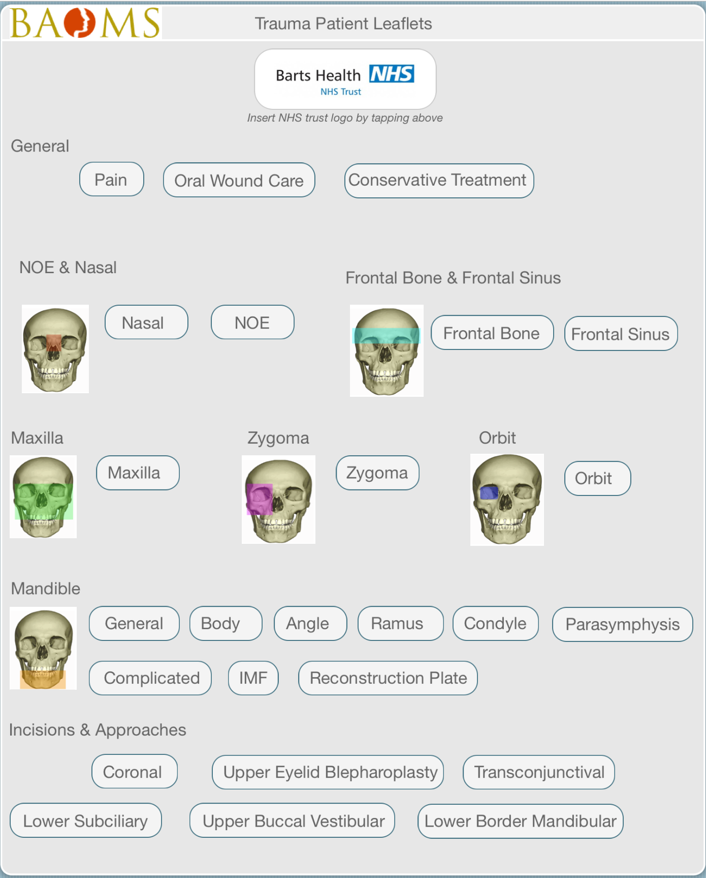

Figure 1: navigational home screen (subsections link to further informational screens detailed below)
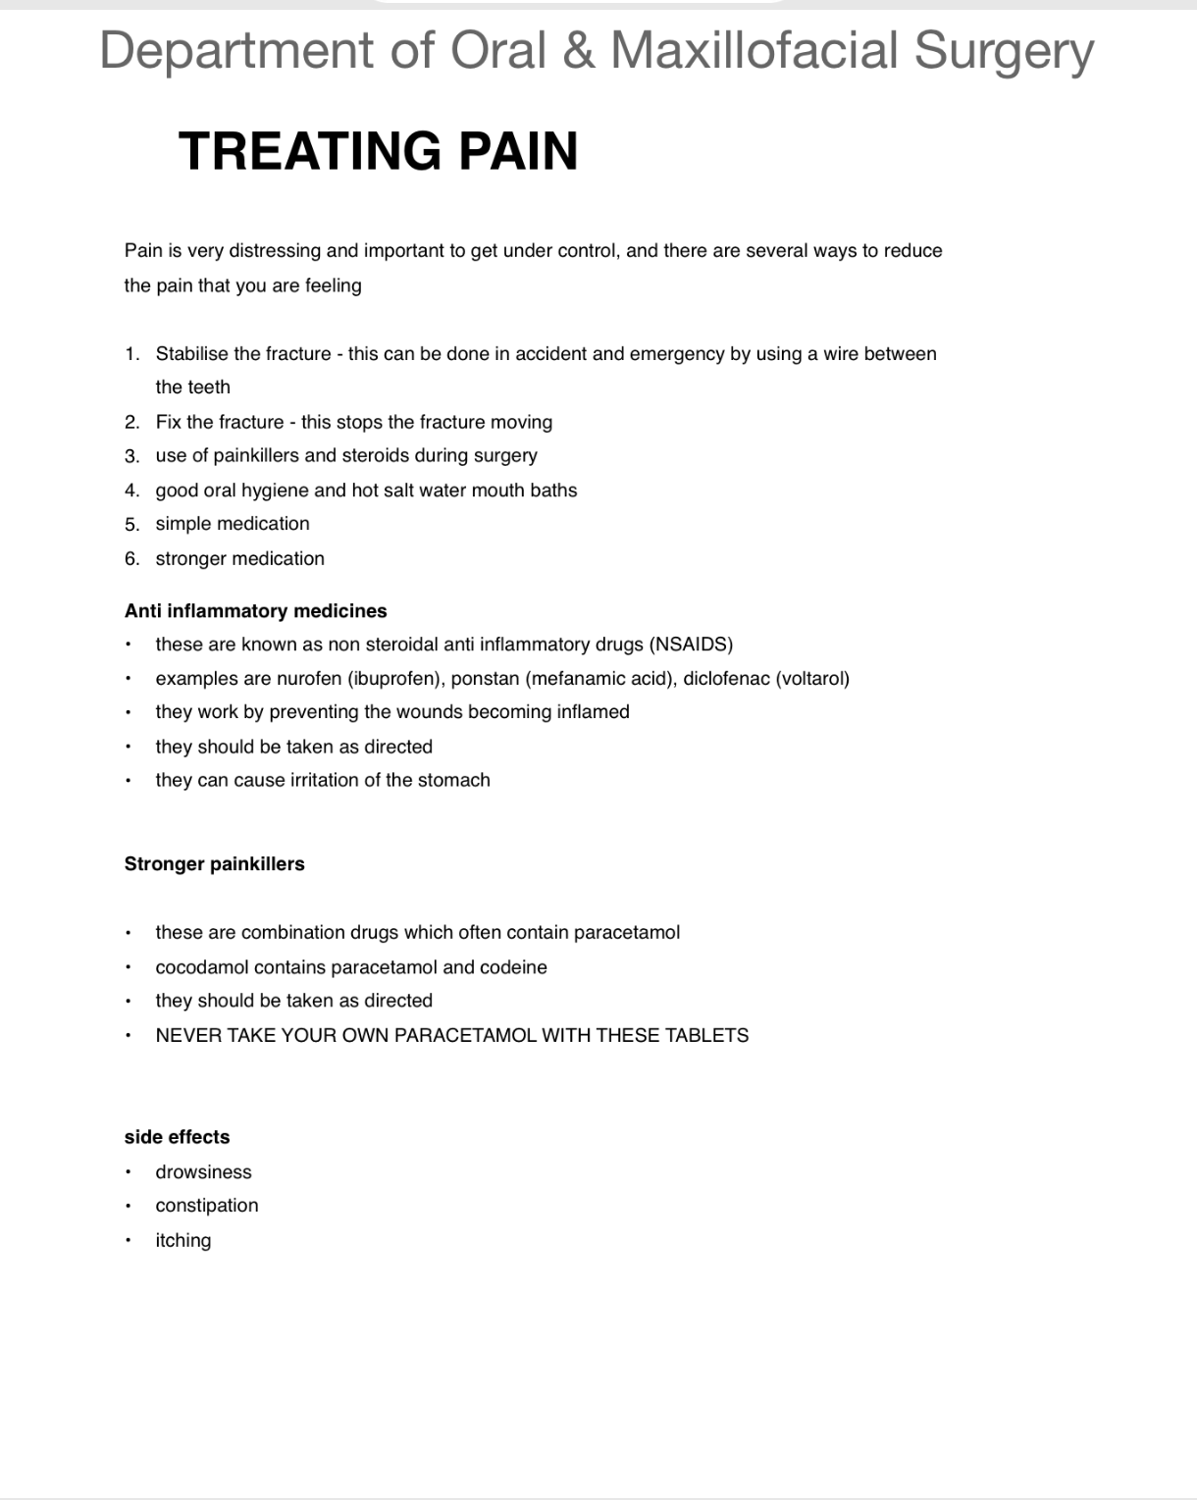

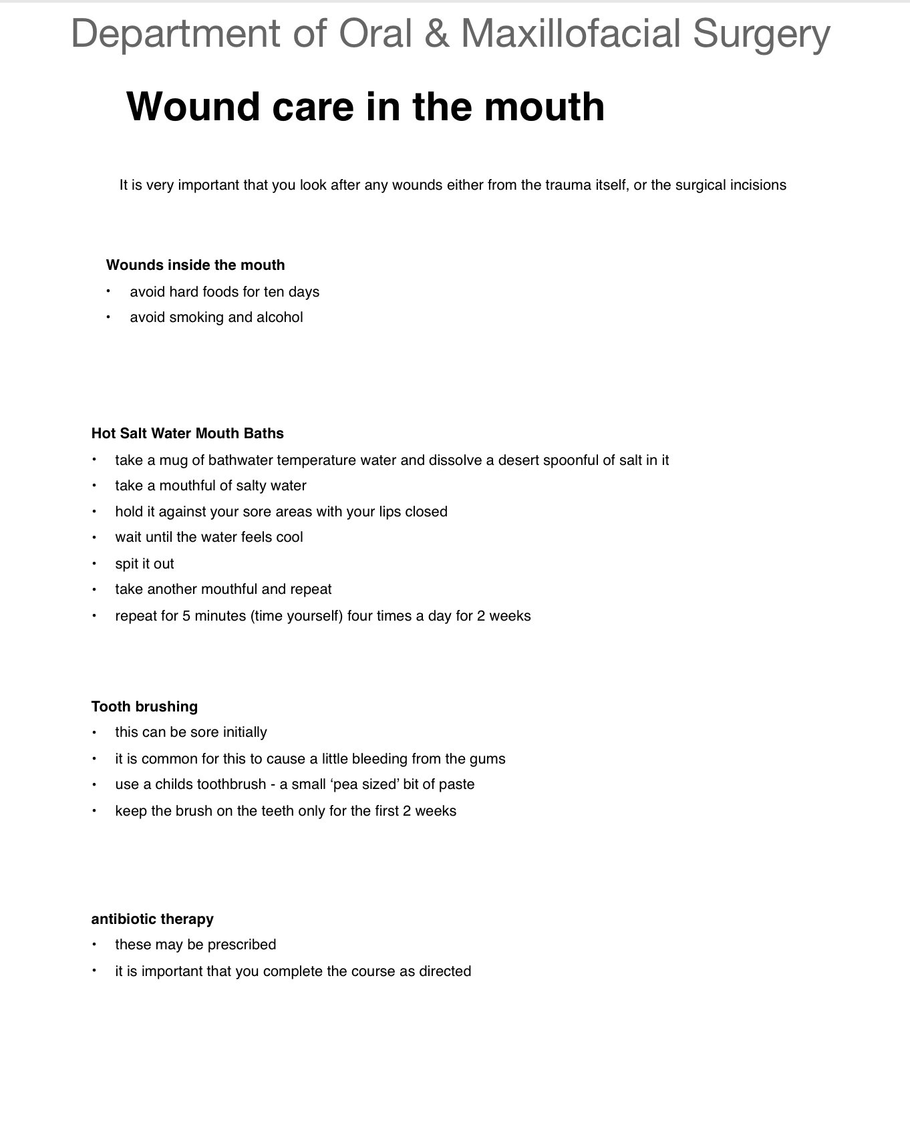

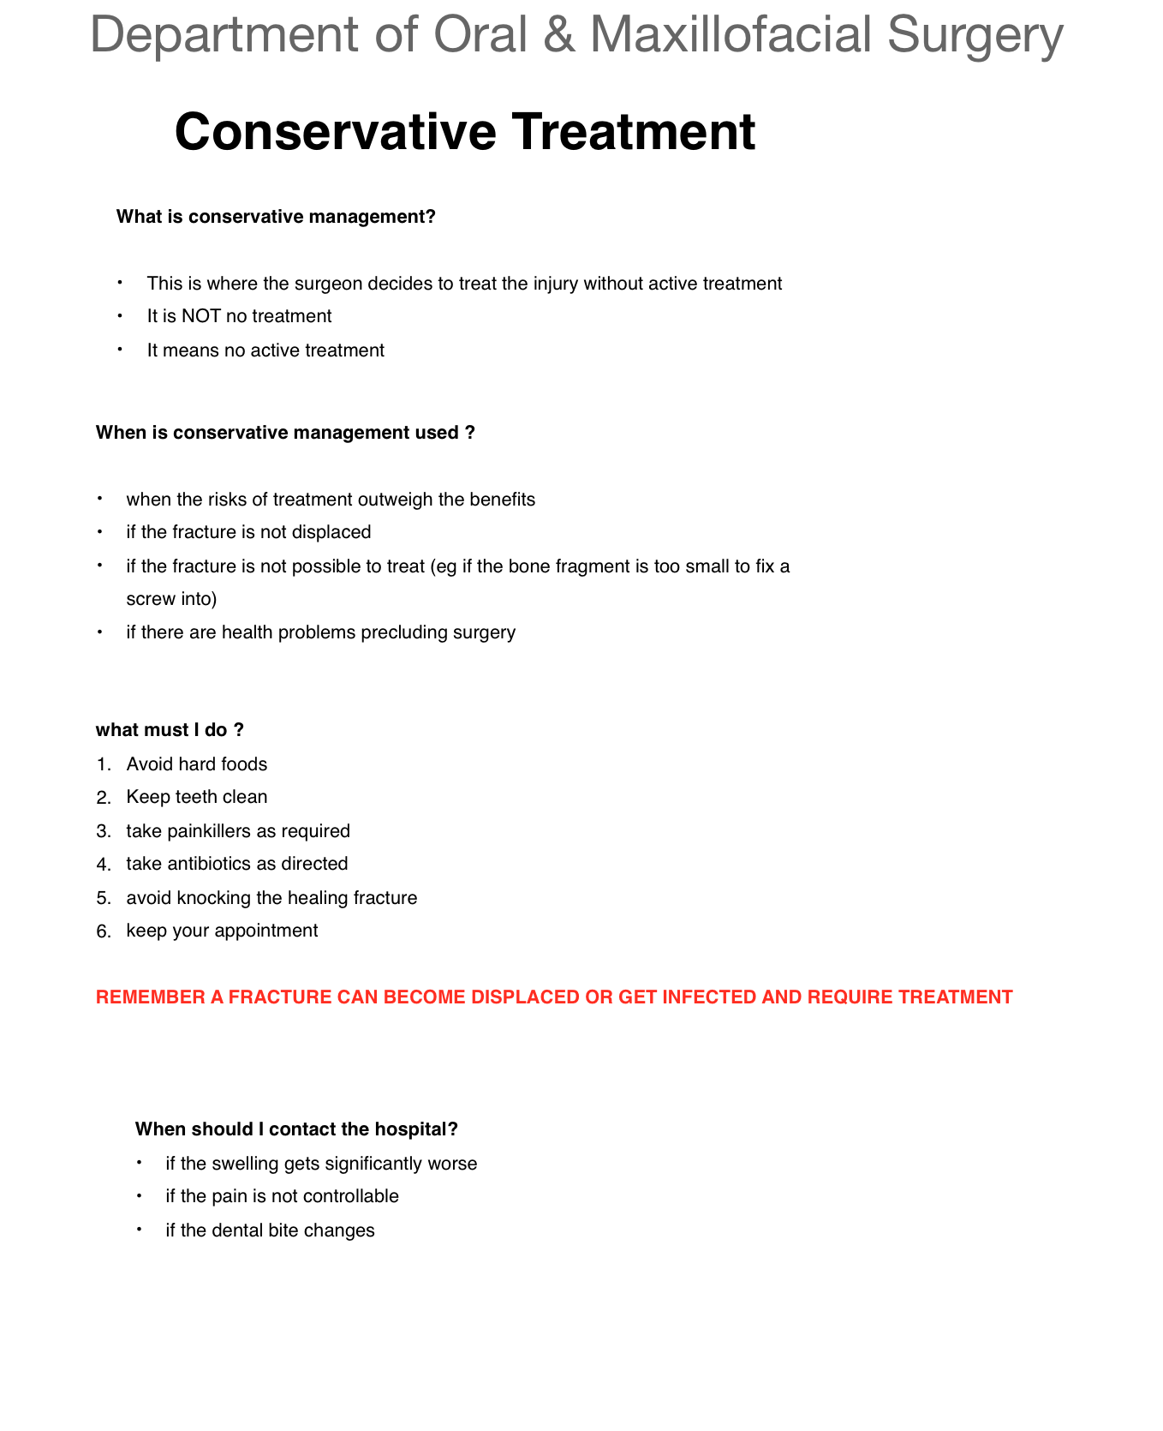

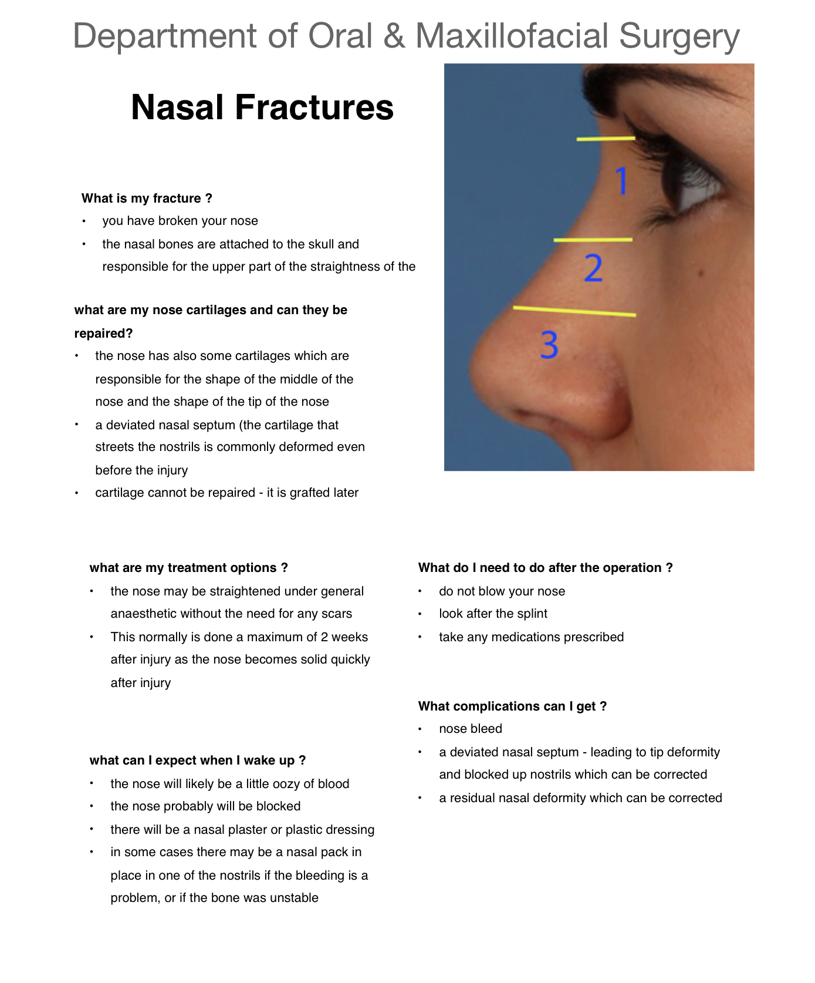
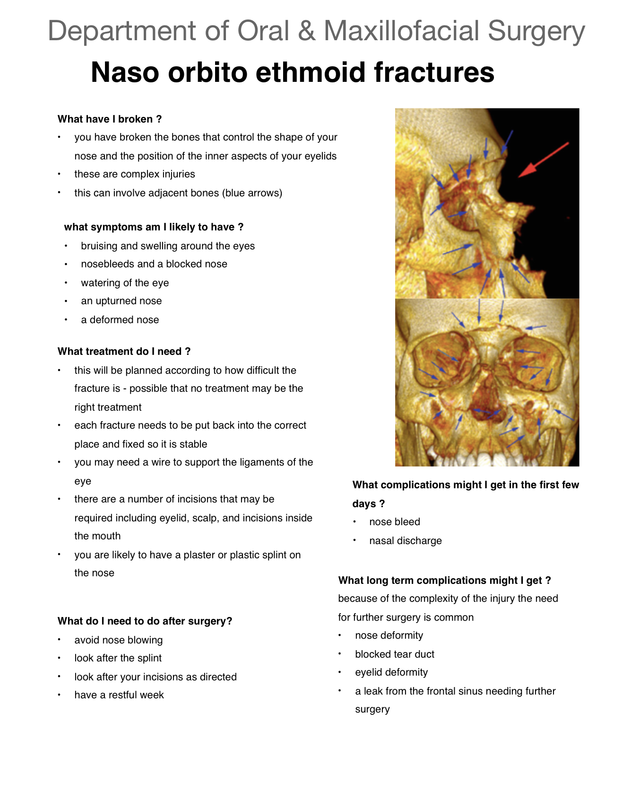
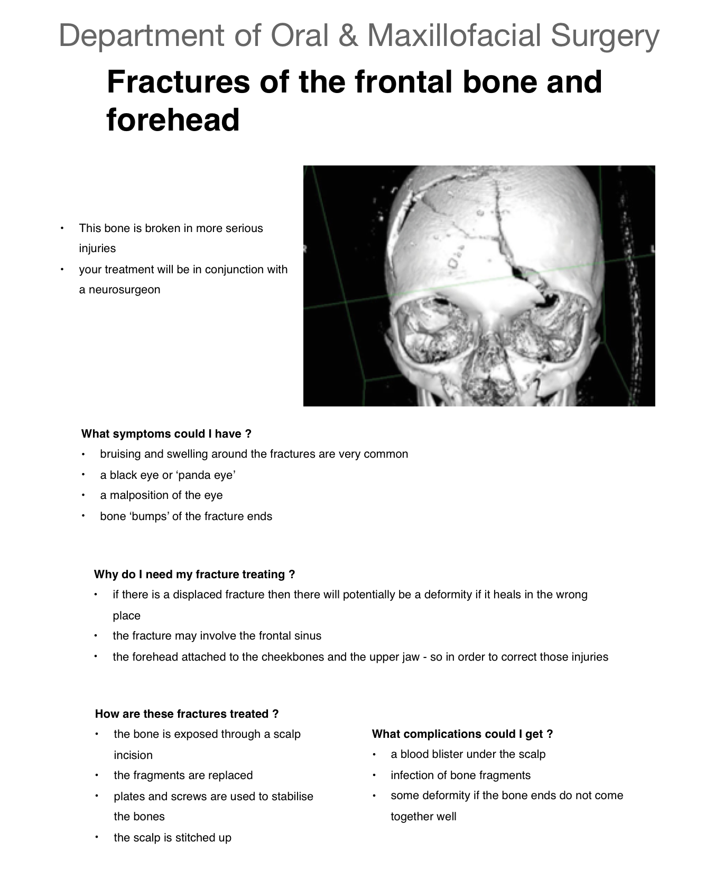

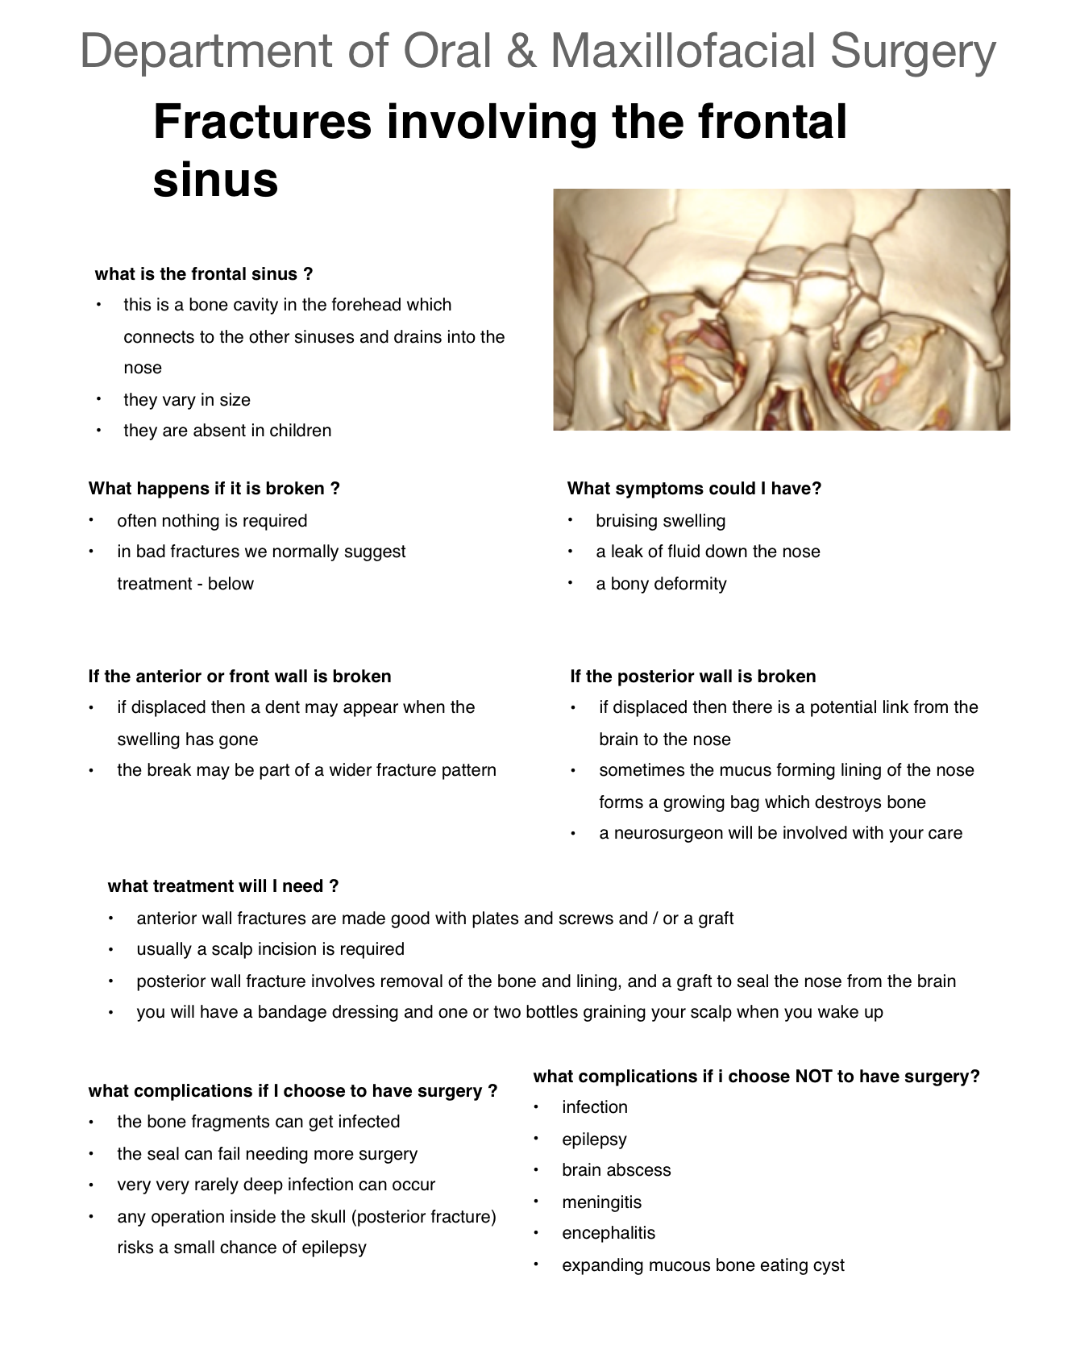

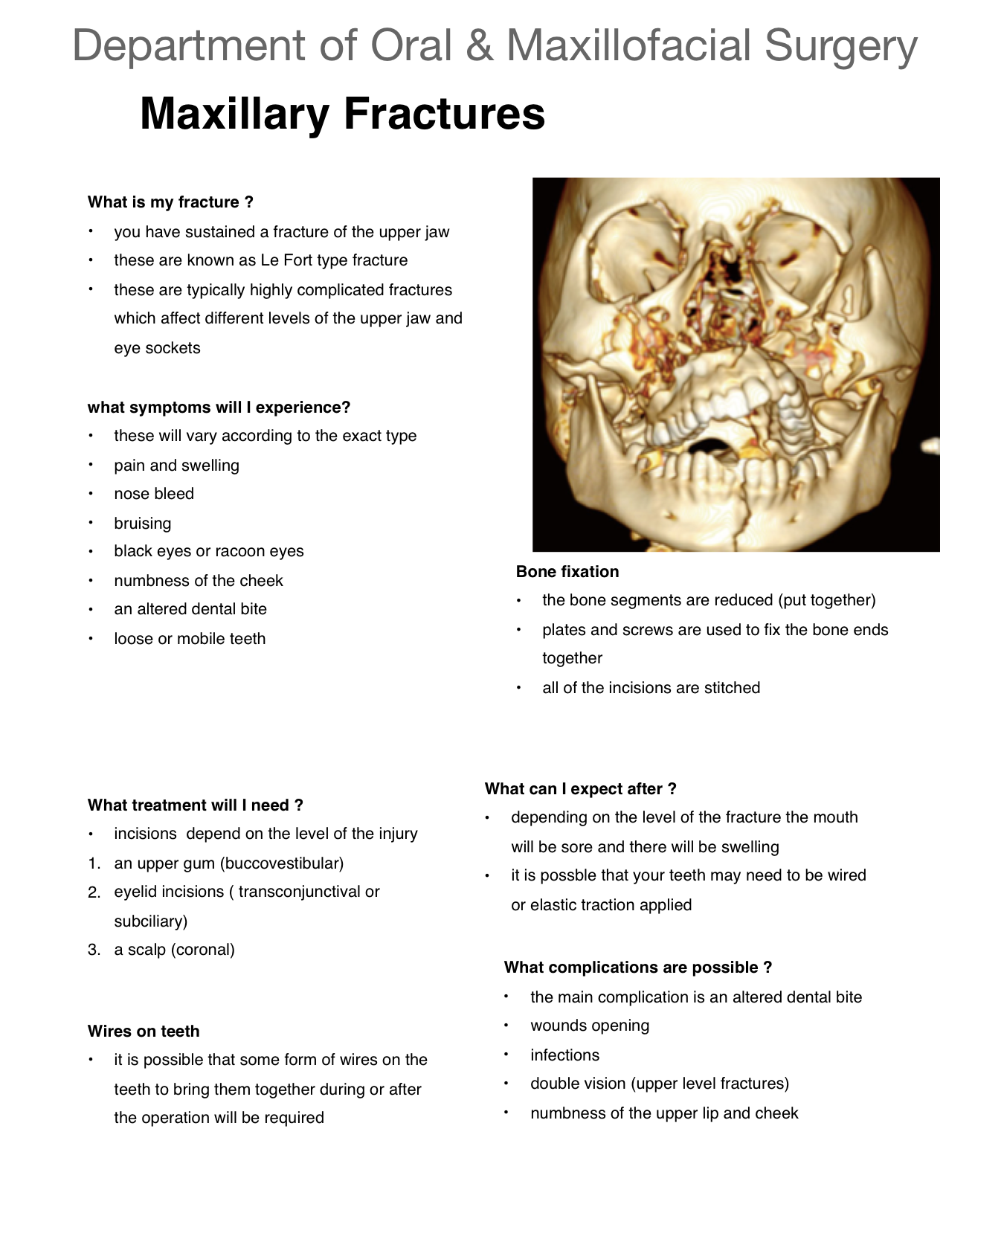

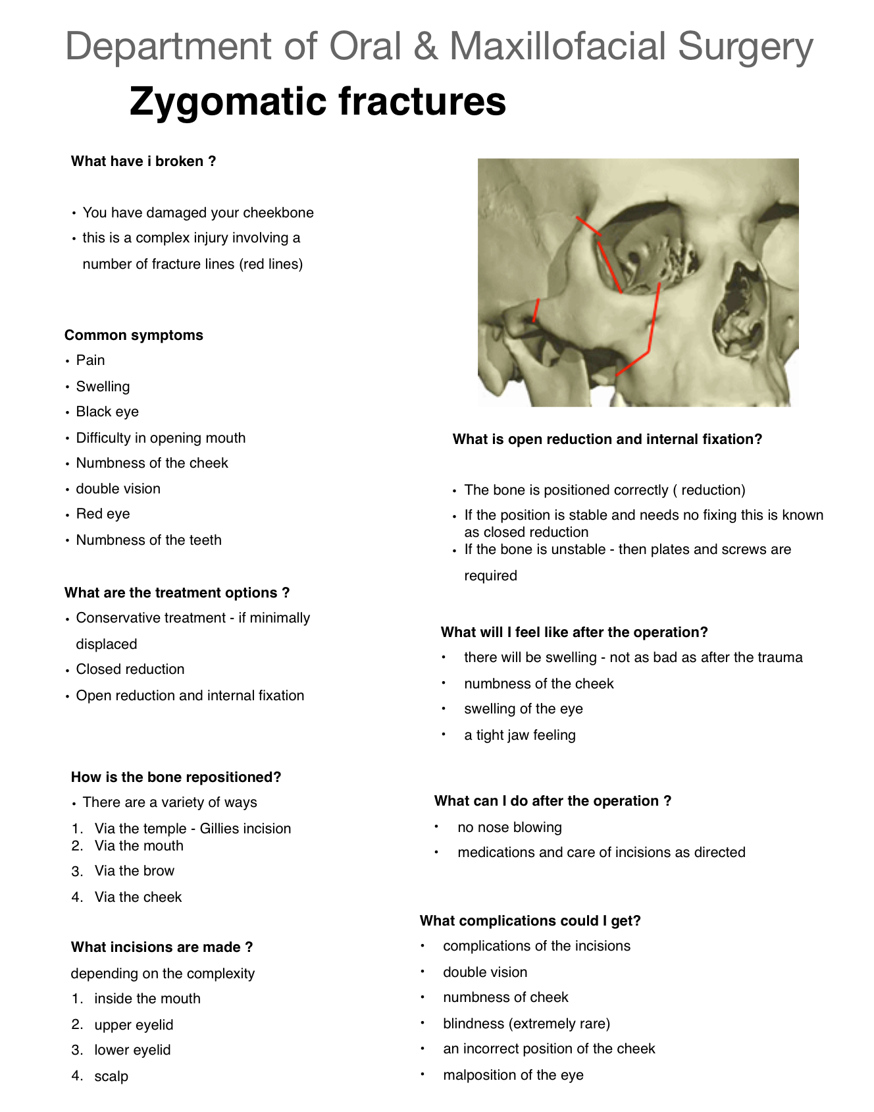

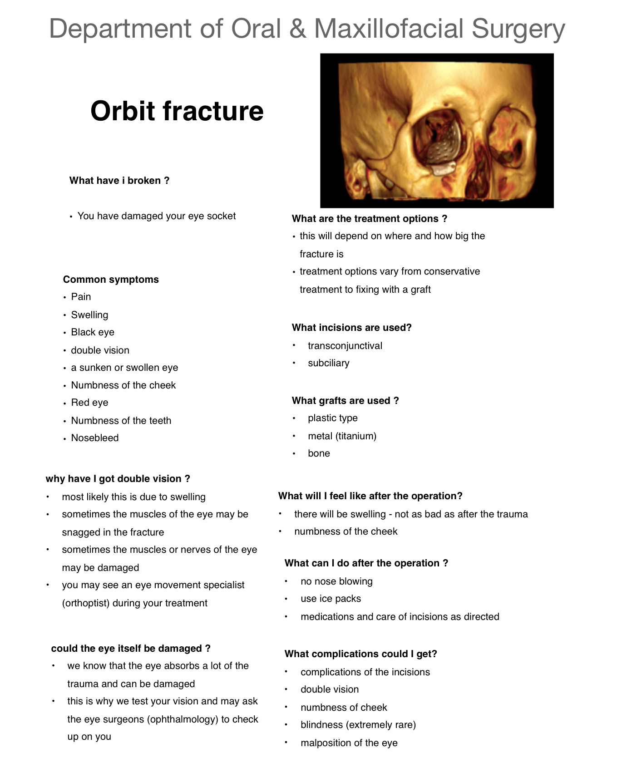

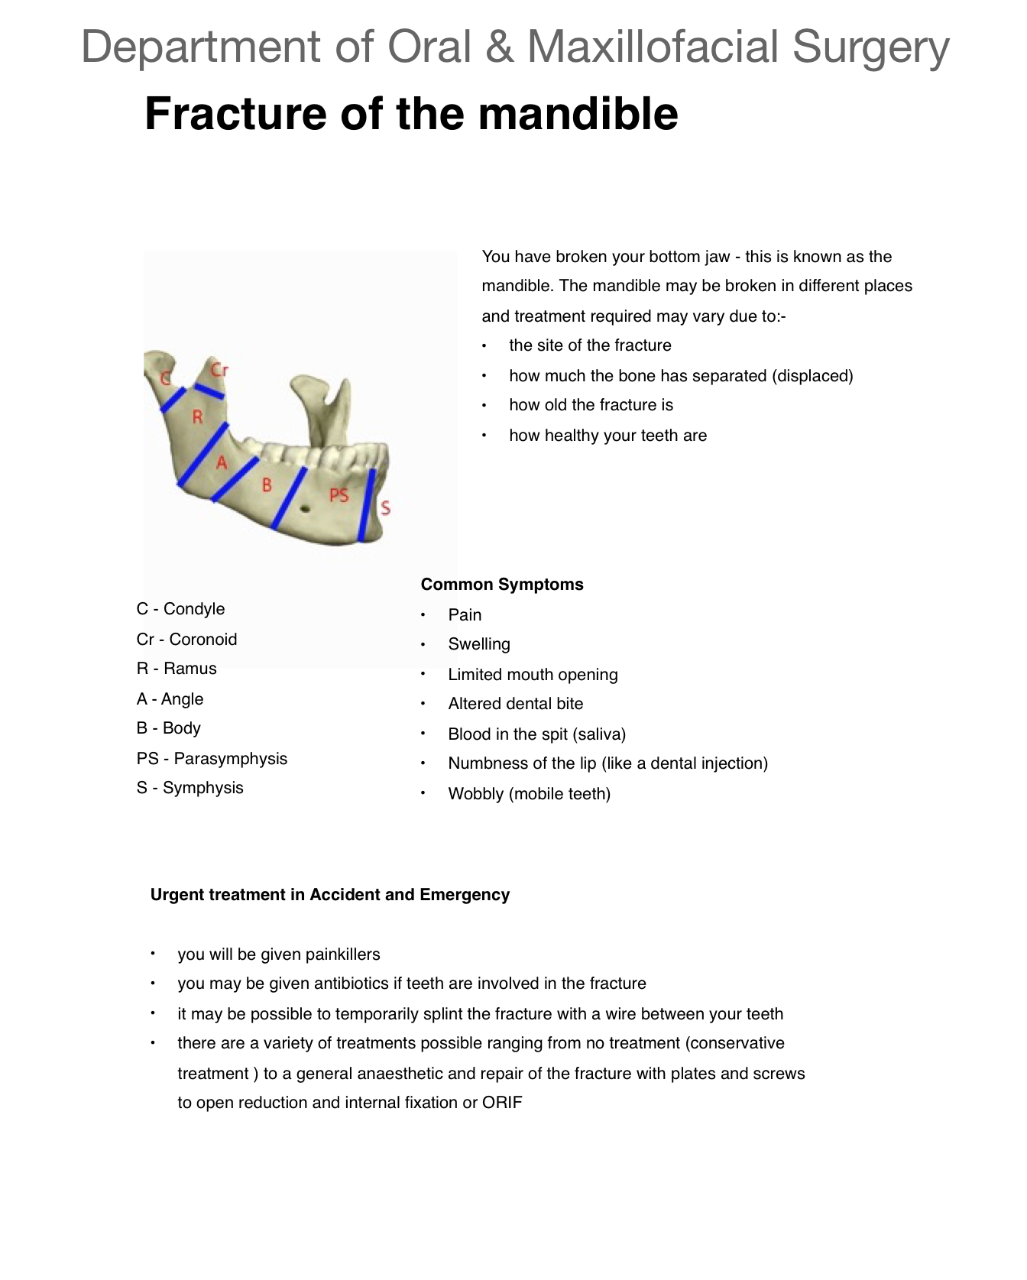
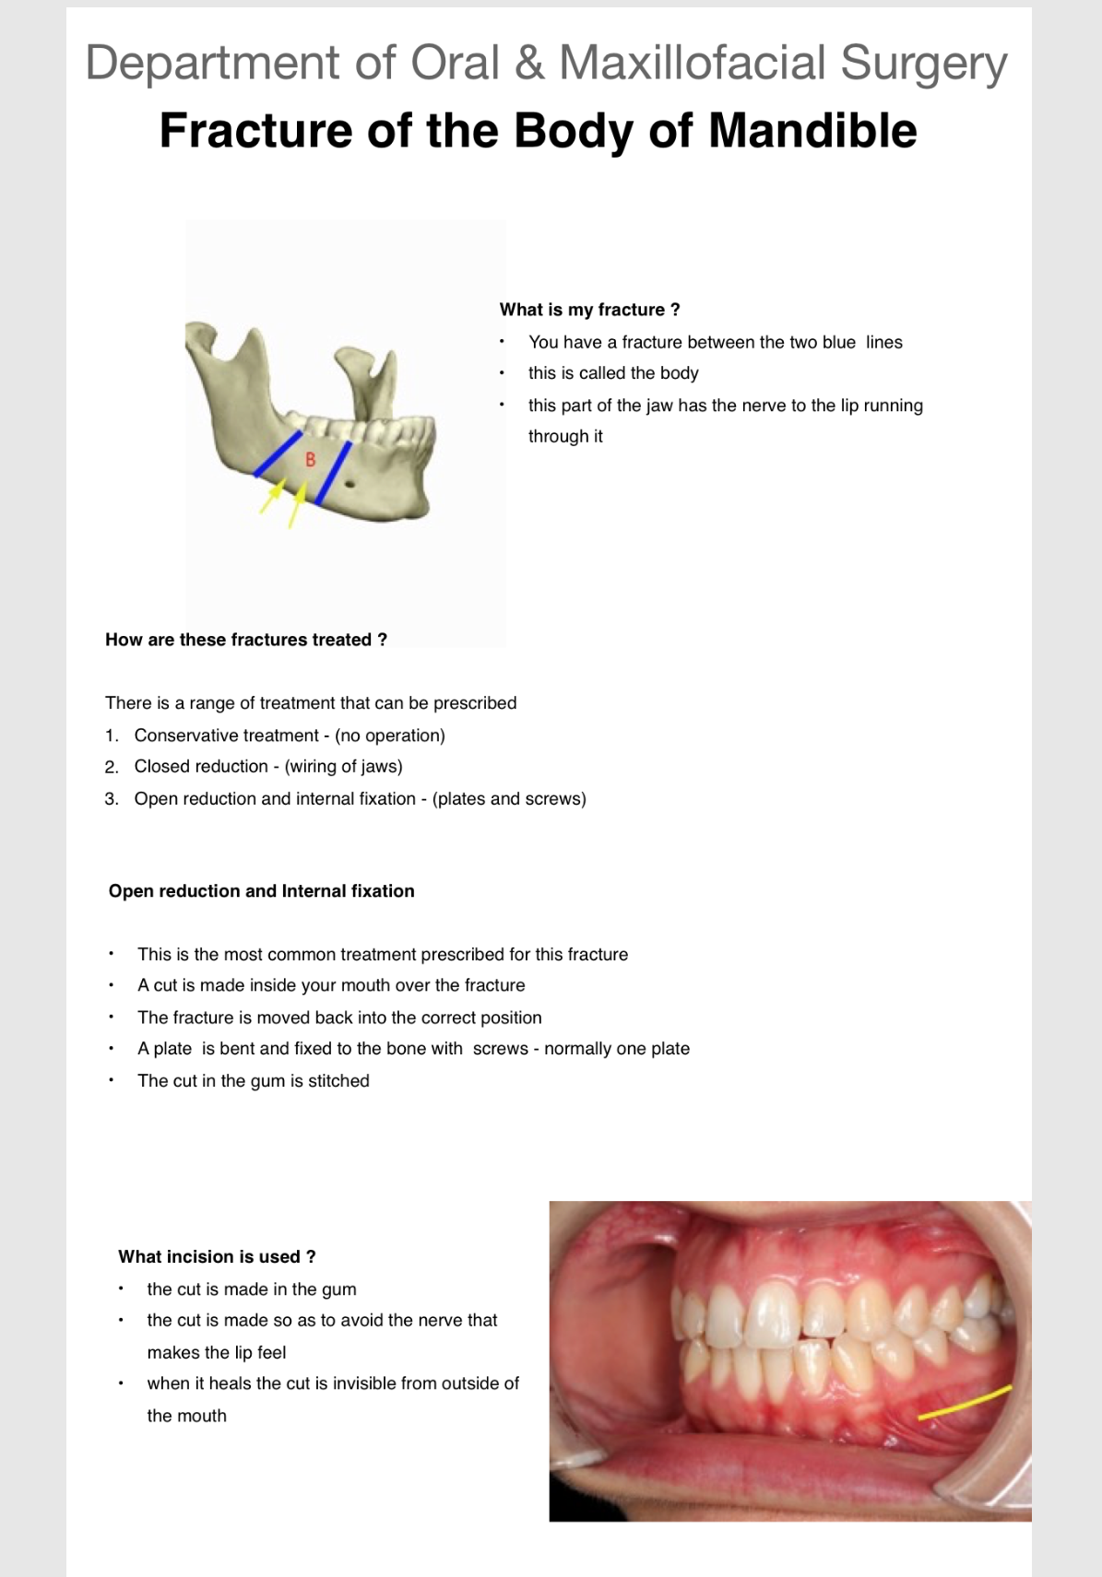

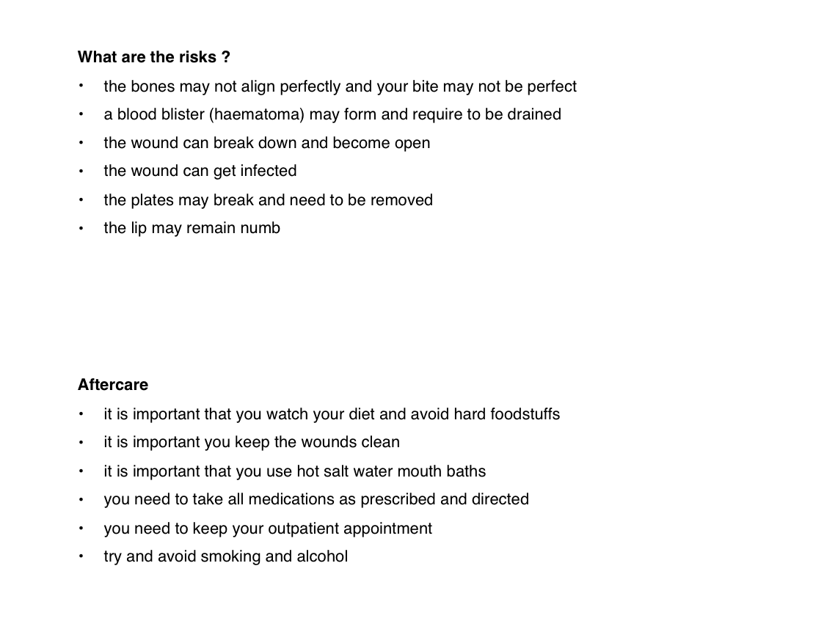

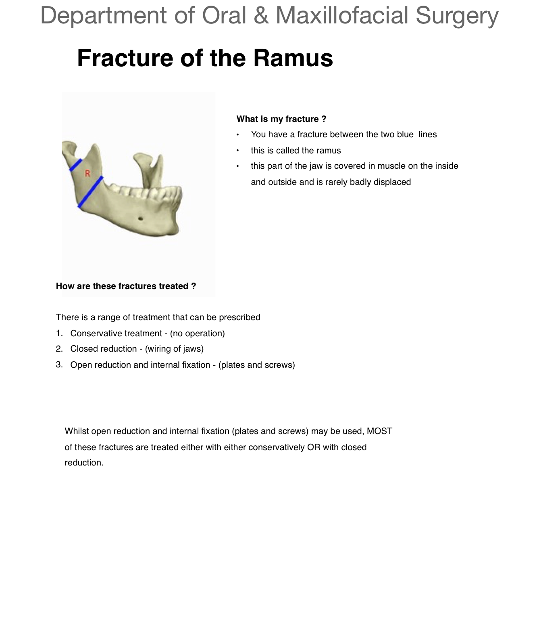

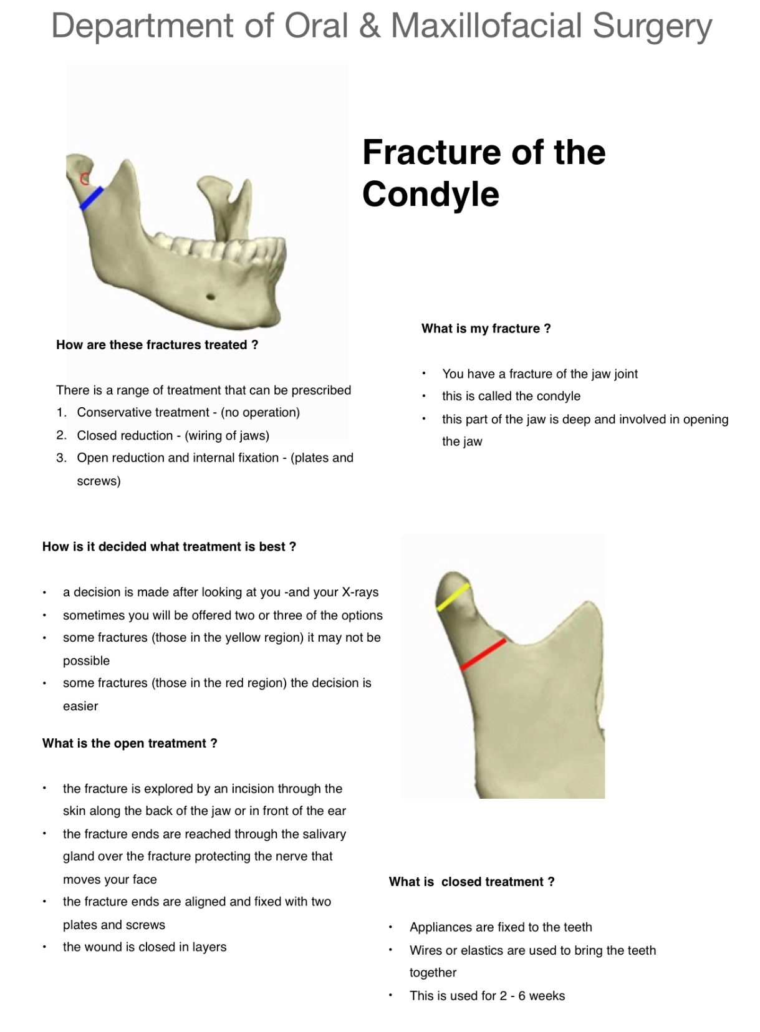

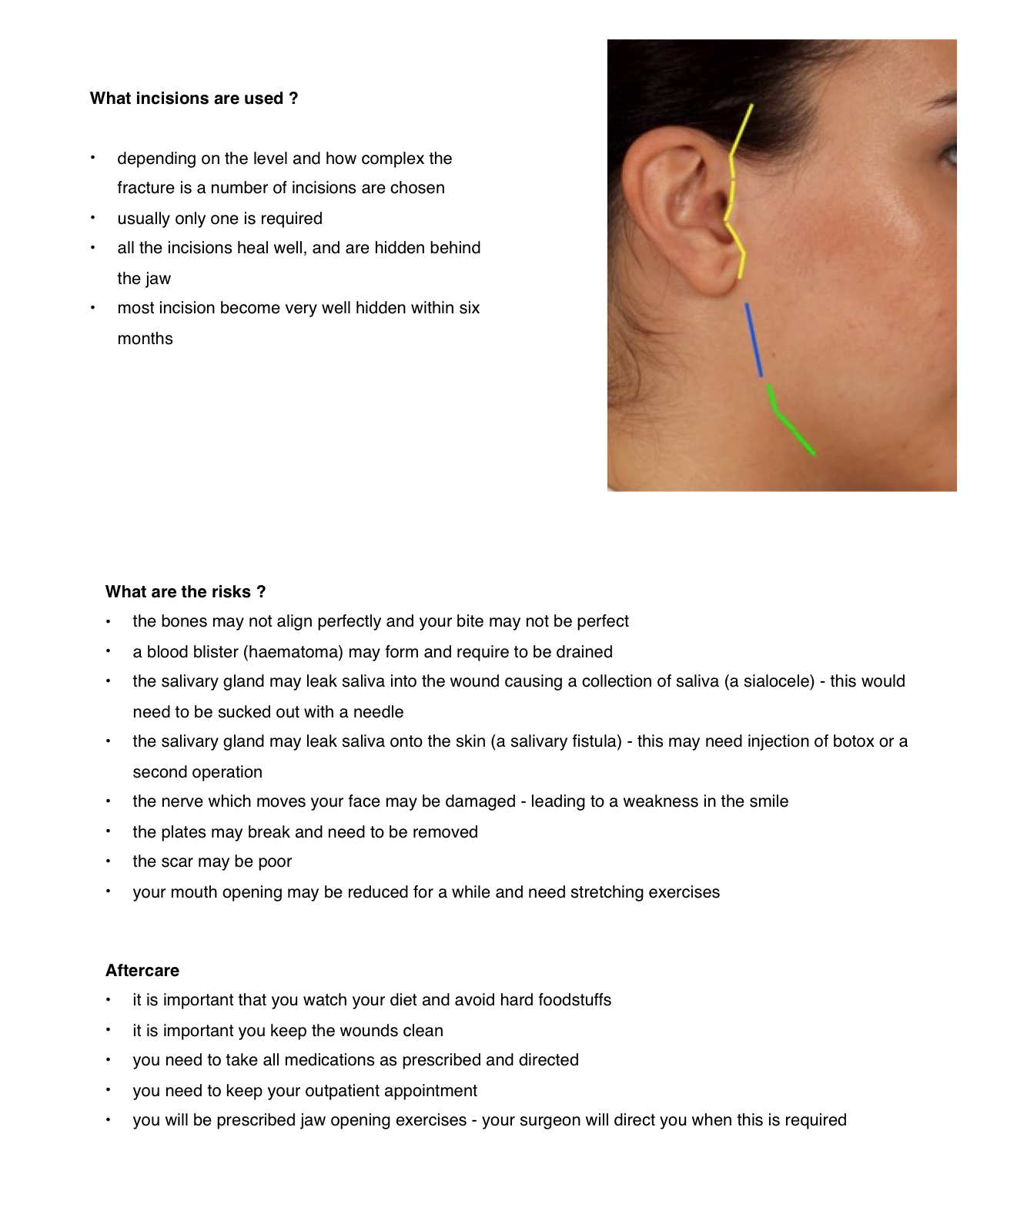

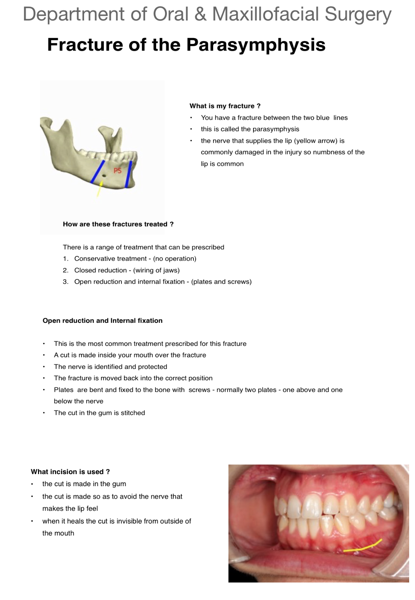
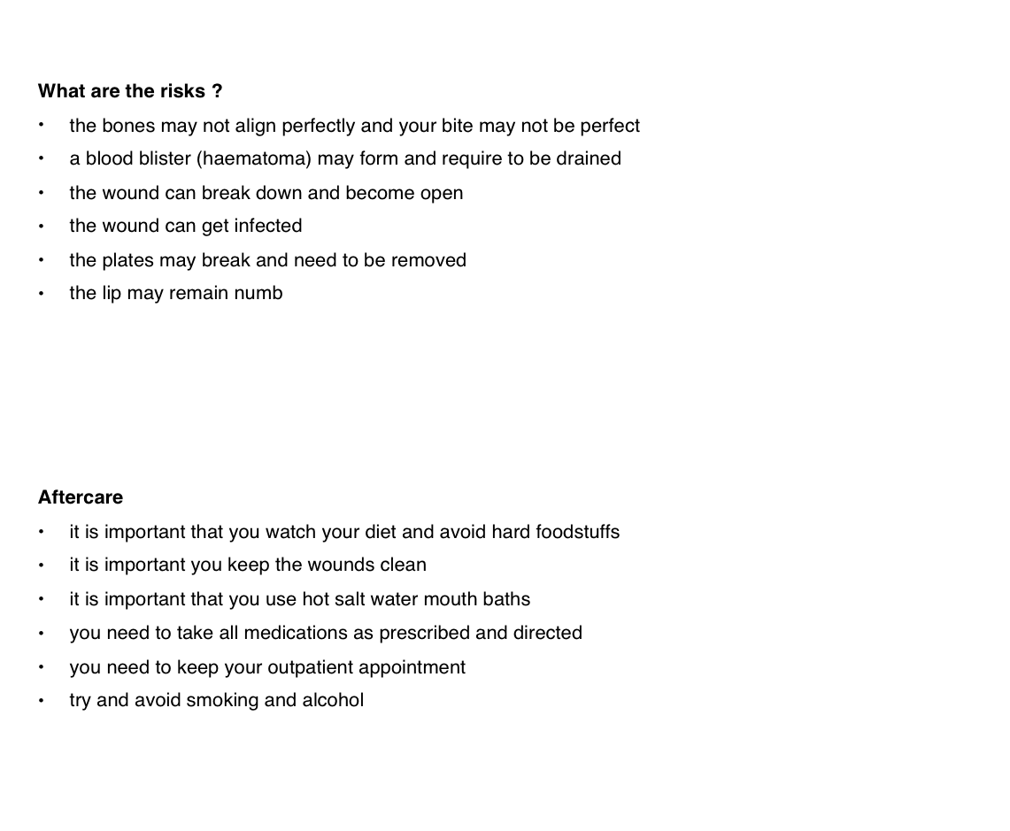
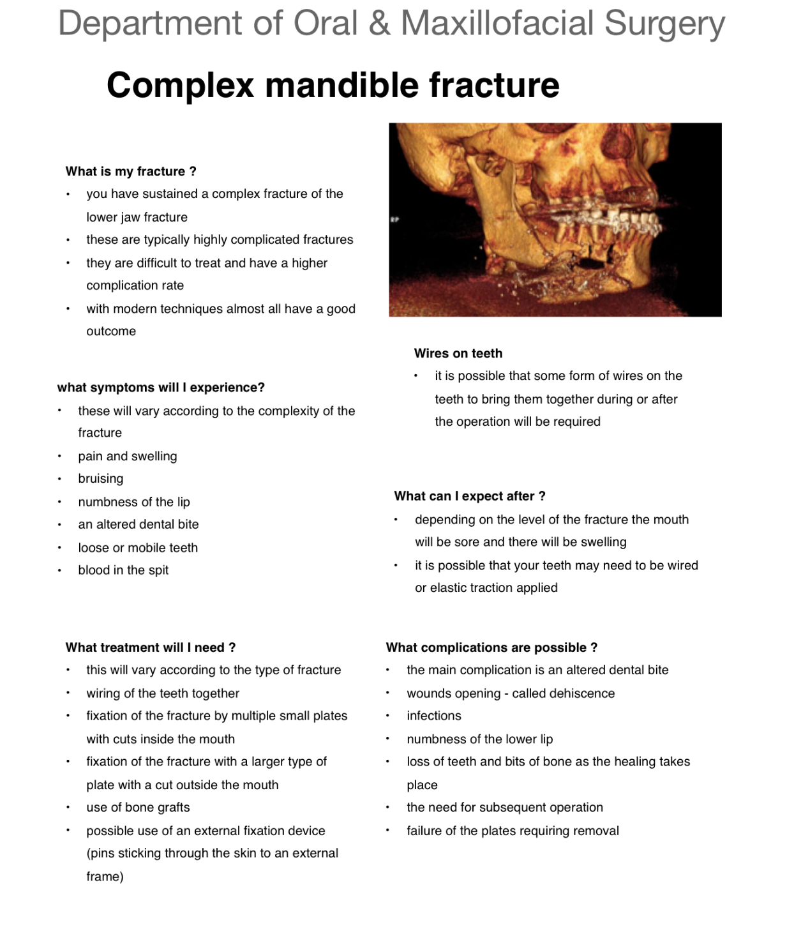

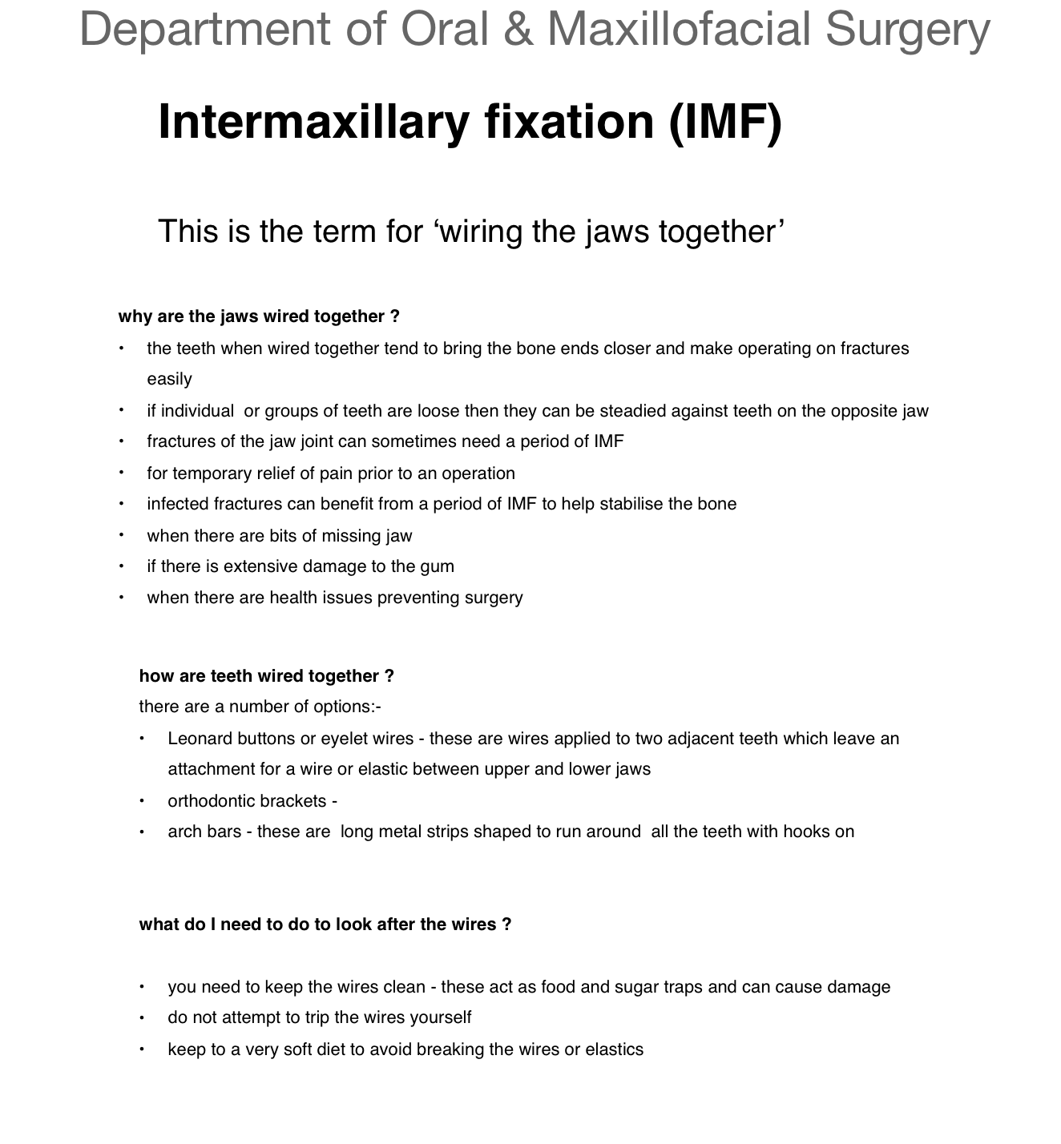
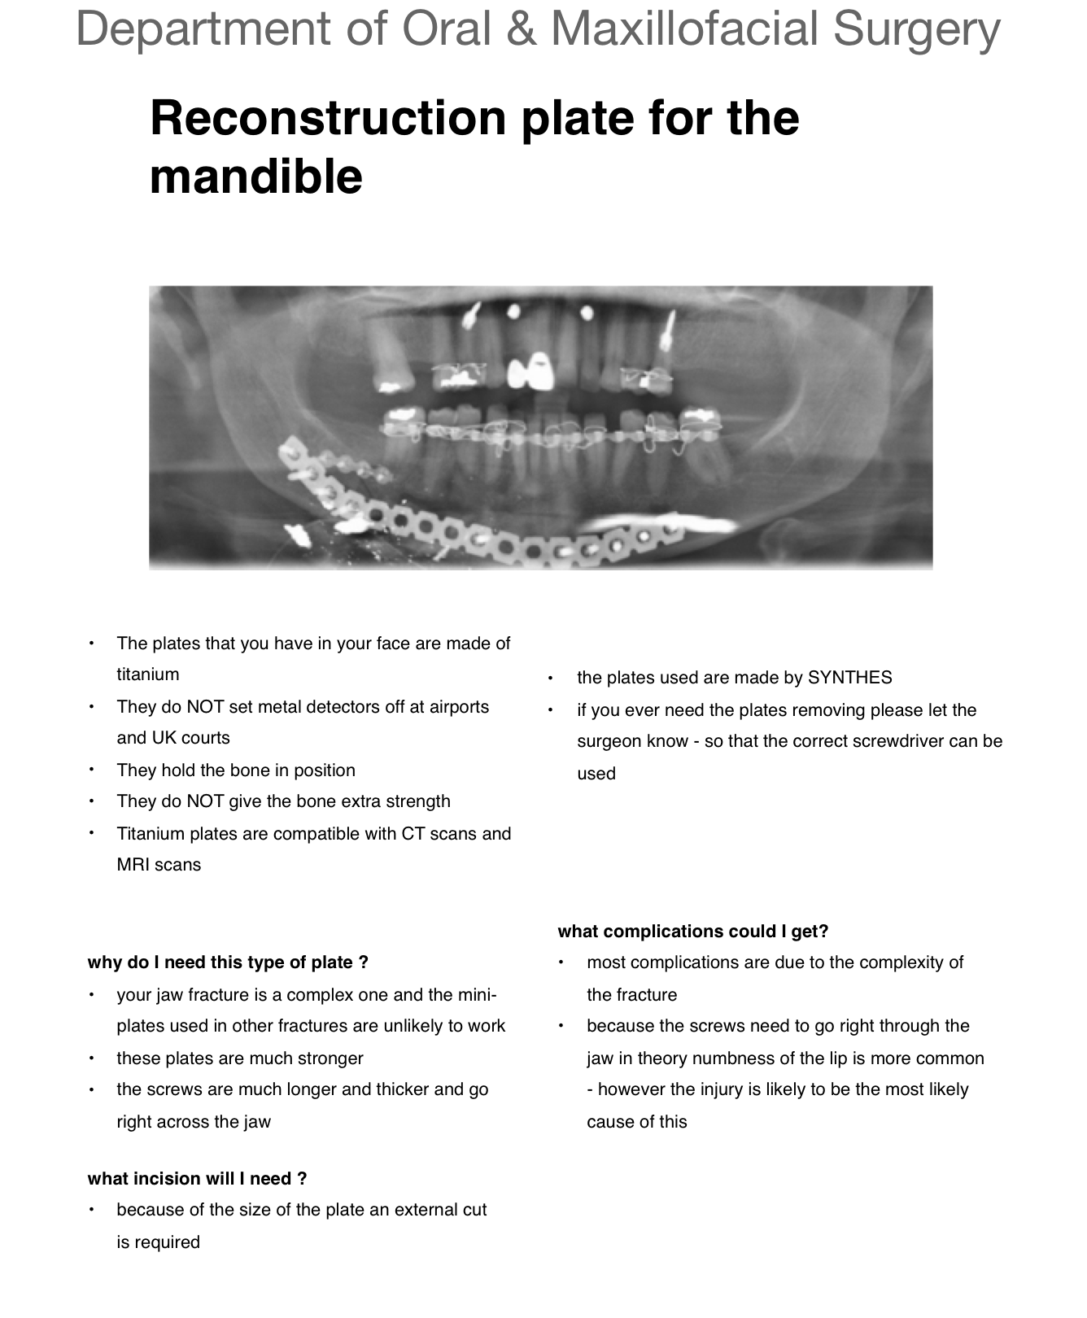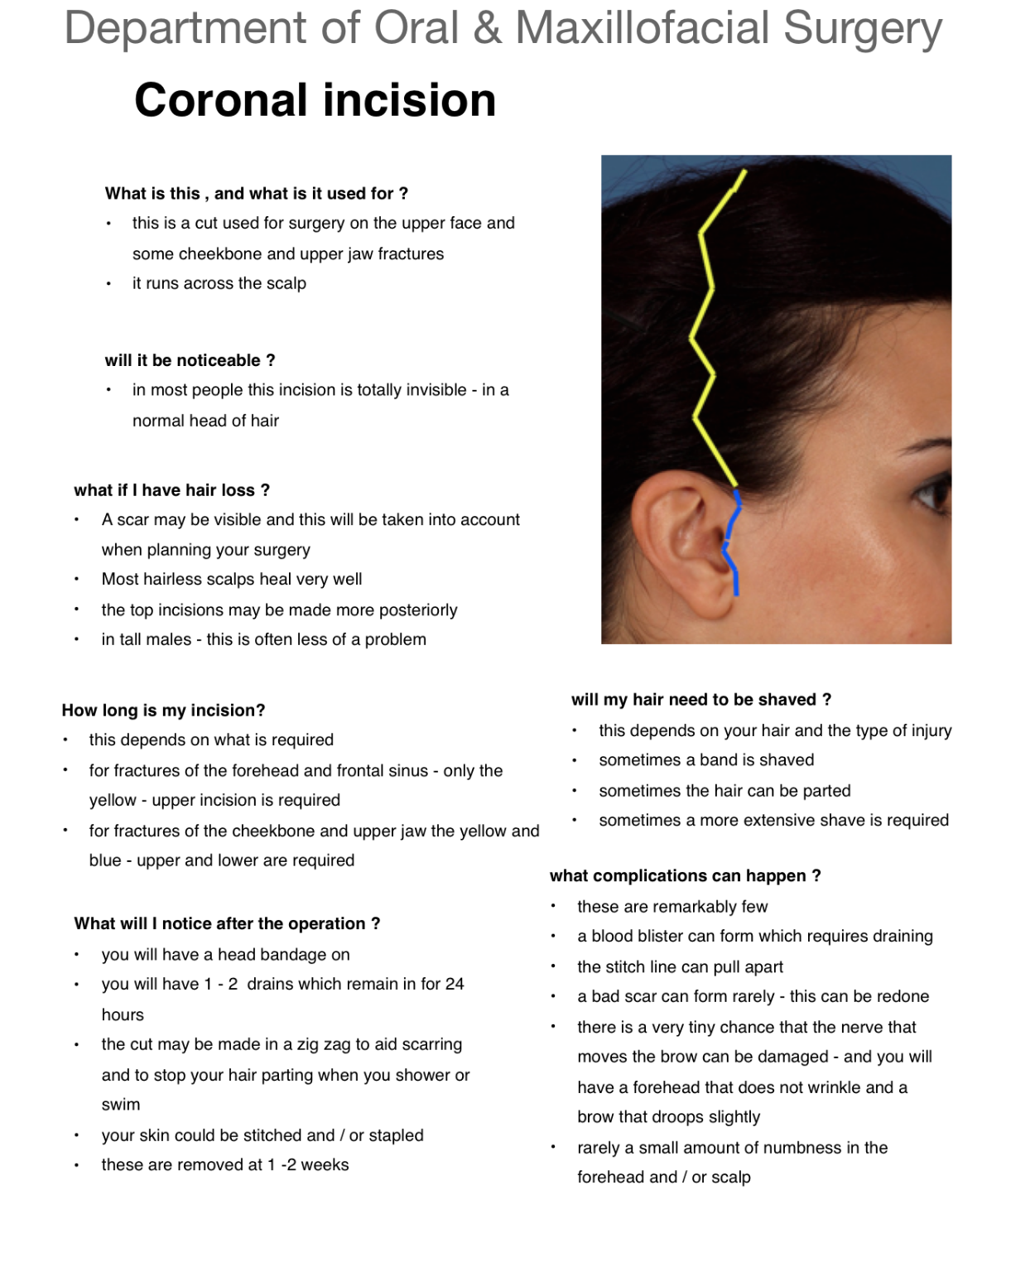
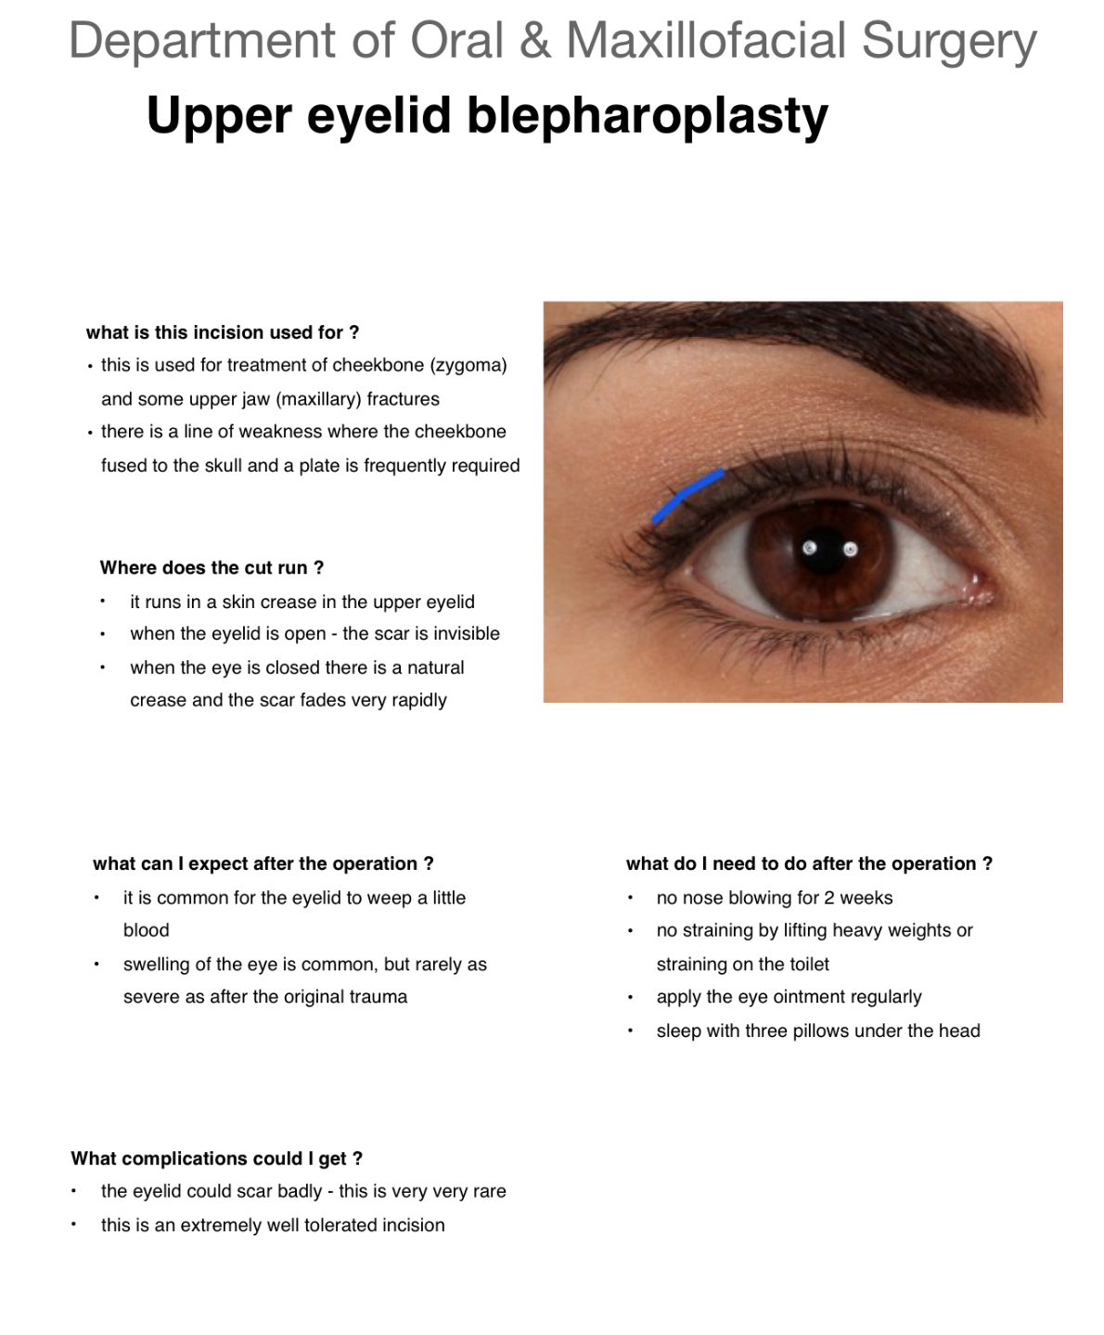

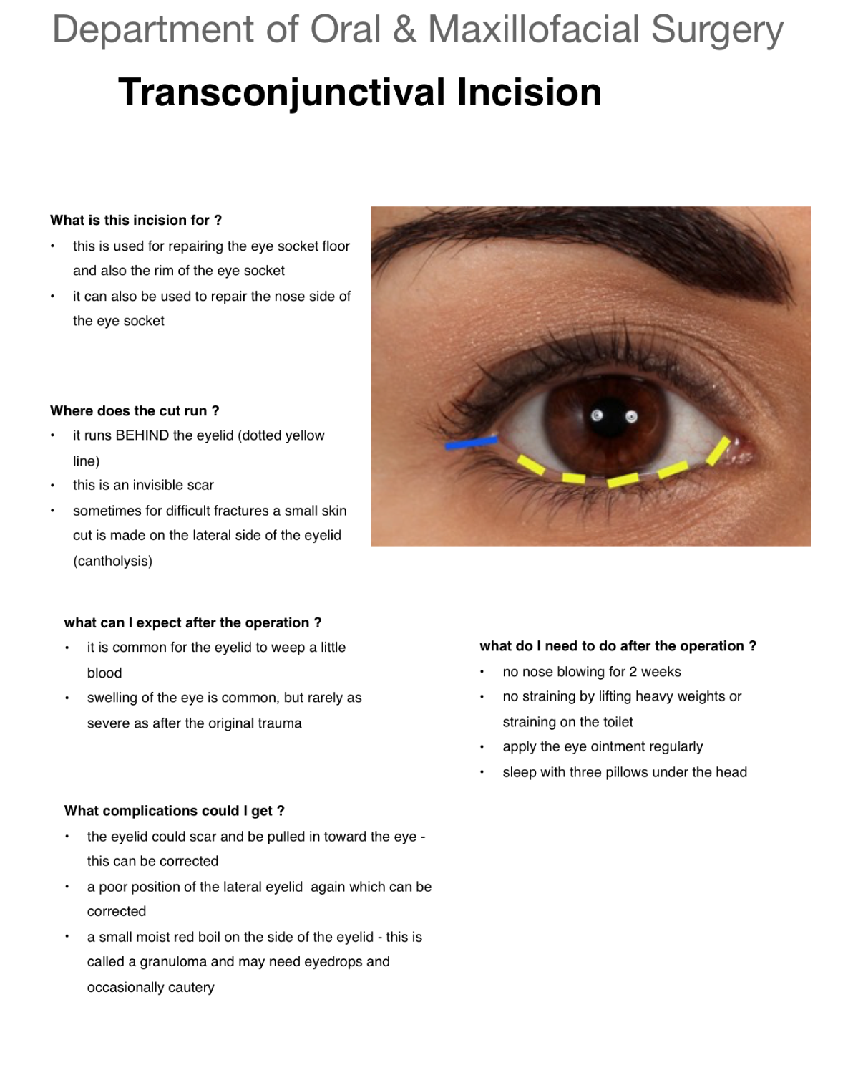
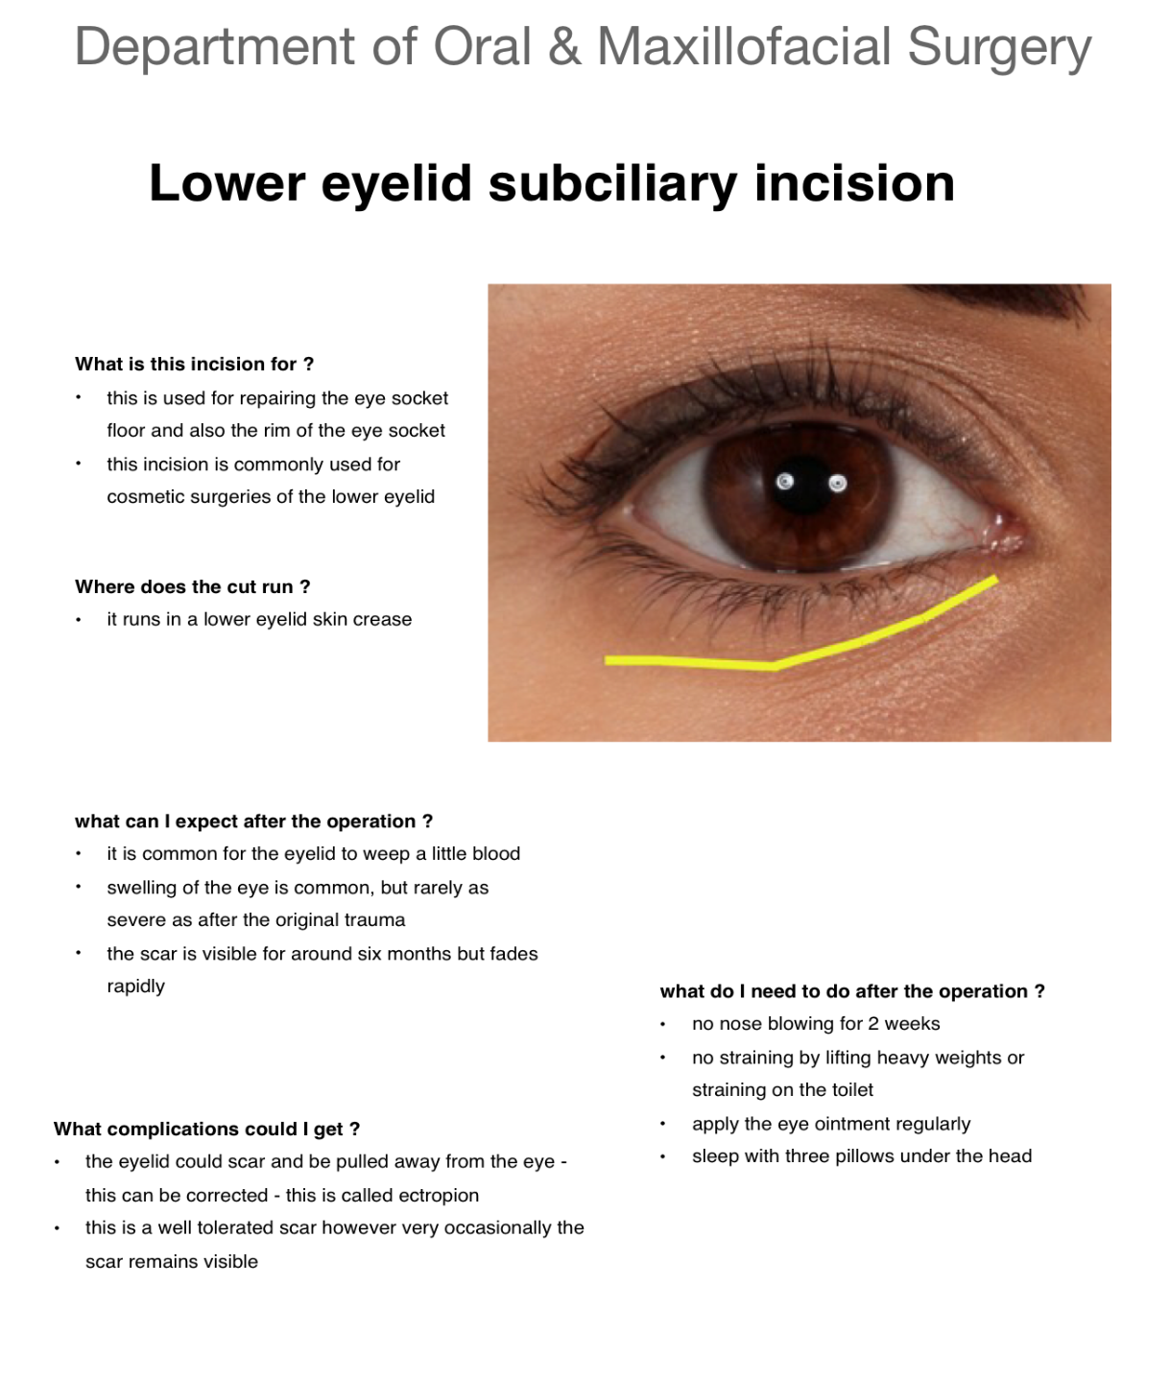

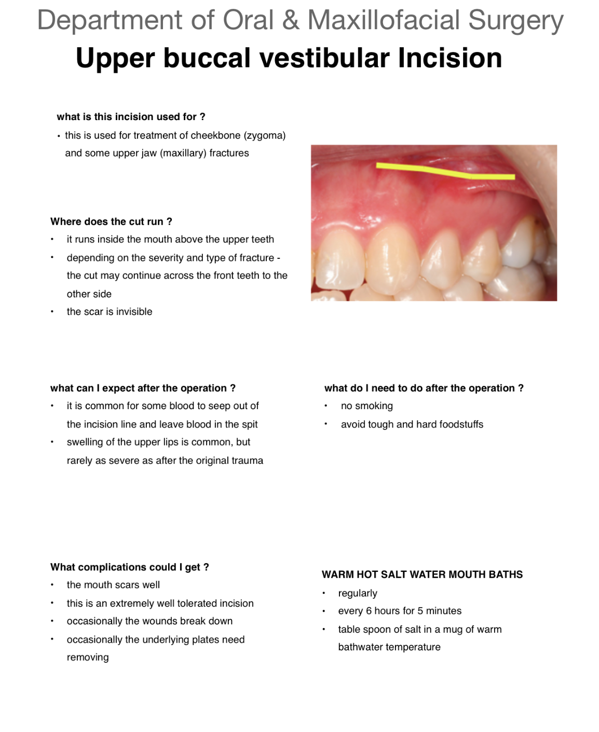

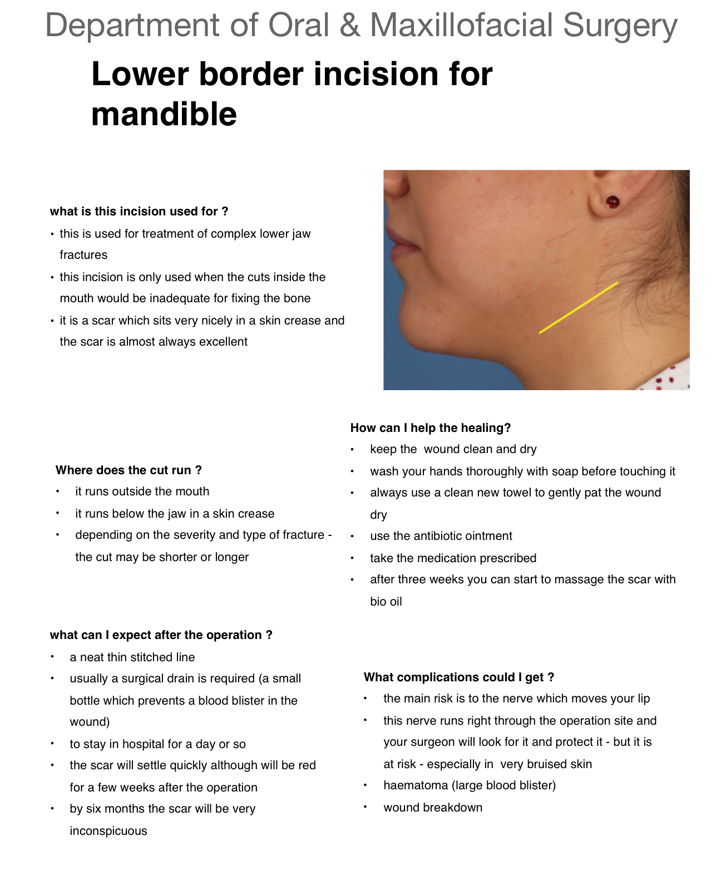

References

- Martins CJ, Keim FS, de Santa ET. Epidemiological characteristics of trauma patients Maxillofacial Surgery at the hospital Geral de Blumenau SC from 2004 to 2009. International archives of Otorhinolaryngology.
- Zbar RI, Otake LR, Miller MJ, Persing JA, Dingman DL. Web-based medicine as a means to establish centers of surgical excellence in the developing world. Plastic and reconstructive surgery. 2001 Aug;108(2):460-5. PubMed PMID: 11496192.
- Mistiaen P, Poot E. Telephone follow-up, initiated by a hospital-based health professional, for postdischarge problems in patients discharged from hospital to home. The Cochrane database of systematic reviews. 2006 (4):CD004510. PubMed PMID: 17054207.
- http://mobilemarketingmagazine.com/
- https://www.gov.uk/government/uploads/system/uploads/attachment_data/file/328405/Best_practice_guidance_on_patient_information_leaflets.pdf
- http://ec.europa.eu/health/files/eudralex/vol2/c/2009_01_12_readability_guideline_final_en.pdf

